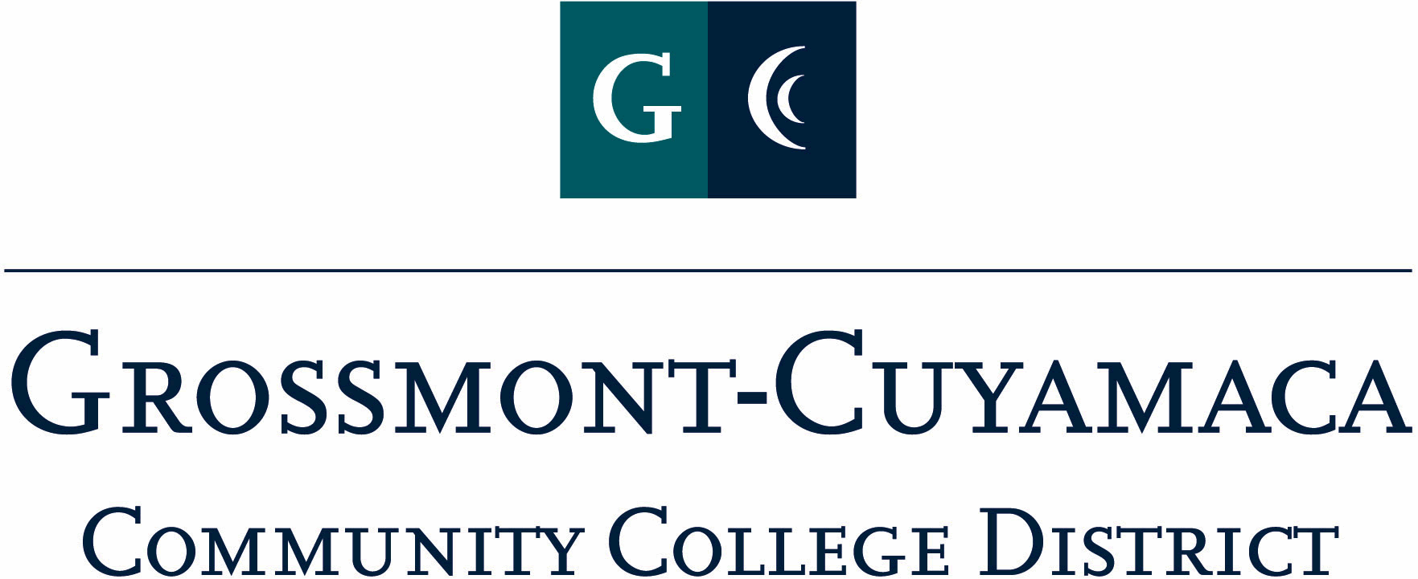
CLASSIFIED SENATE
EXECUTIVE BOARD MEETING
09/01/2009– Meeting Minutes

Members Present: Debi Miller, Paula Tillery, Patricia Bailey, Monica Farris, Kimberly Gioscia, Wendy Corbin, Yvette Macy, Maria Briney, Angela Johnson, Scott Howell, JacQueline Osborne, Pat Murray, Karen Ostegard, Karen McCoy
Members Absent: Laura Murphey
Members Excused: Tasa Campos, Maggie Gonzales, Avelina Wilder, Serene Pritchett (frozen), Jean Wallace

1. Welcome and Call to Order

The meeting was called to order at 12:07 pm.

Pat Murray introduced Ernie Ewin, Grossmont College Foundation President, and the opportunity to support a scholarship opportunity. E. Ewin explained the Osher Foundation endowment that was afforded to all community colleges through the state. Each college has been challenged to raise funds by 6/2011 and matched by the Osher Foundation. How it works: For every dollar that is contributed the Osher Foundation will match ½ and establish scholarships in perpetuity. Grossmont College’s goal is: 20 scholarships. He reported that a scholarship had been set up in Beth Lebkuecher’s name and $10,300 have been raised. Ernie explained the magic number is $13,500. Additional challenge is to raise enough money at both college to afford 50 scholarships in time for the district’s 50th anniversary. The contribution is tax deductible. Pat Murray has material that details the program.

The group asked a few follow-up questions on the matter. Scott Howell asked how much money does it cost and for how long. Ernie responded if you want you can set up a payroll deduction of $18 a month, for 24 months. He also added once the goal is met the scholarship lasts forever.

2. Approval of Minutes from July 14, 2009

The minutes from 07/14/2009 Meeting were approved. M/S/A Rose/Gioscia. The motion was approved unanimously.

3. Communication

VP Reports

District: District: W. Corbin reported out the involvement of Classified staff with students during the 1st week of classes went well. She suggested that we have T-Shirts made for CS and plan to be available on campus as well as at a table. J. Osborne added that it was an idea generated from A. Johnson and that both her and Angela volunteered to come in ½ hour early to work and stay one hour later after work during the first week of class to help assist students with their inquiries. They worked closely with Lorenzo from the student body and would like to expand the Classified Senate presence.

The President suggested a committee be established to organize this event at both campuses and suggested that representatives from 3 locations be involved with the committee. An e-mail will go out soliciting volunteers. Angela Johnson volunteered to Chair this Committee, and will report back to the group on the progress. The President will send an e-mail out to those interested in being on this committee.

Wendy Corbin continued her report by updating the group on the EEO Task Force. The report is available on the intranet at Grossmont College. The Chancellor is in the preliminary stages of presenting to the district.

She also informed the group of the Benefits Fair that is scheduled for October 26 and 28 and encouraged Classified Senate to be involved by being available to be at a table during the event. The President will solicit the group for interest.

Grossmont: Pat Murray reported the new parking structure grand opening was successful and timely. Enrollment at Grossmont went past 16,000, almost 900 more students than last year. The Budget & Planning council reported a balanced budget based on an approved Tentative Budget. The 1st week of the Assist A Student Campaign was working great. She suggested looking into having more buttons available, perhaps with the CS logo on for those who are helping with students during the first week of classes. The Classified workshop was successful. Grossmont Classified Senate and the President is working on involving Classified more in Convocation. This year she read names of the newly and replaced classified staff at Convocation. Another goal is to collaborate better with convocation planning committee on having classified sign-in. One of the goals from the Retreat was to share publication and she has sent the e-grossmont link to the group.

Cuyamaca: Maggie Gonzales was not available to report.

President’s Report: At the August Governing Board meeting, the Presidents, the Chancellor and Gov Board Trustees who attended the CS Retreat wanted to extend their appreciation to the group on the sharing of ideas and comments. The Retreat debriefing meeting is set for 9/17 at 6:00 at Roundtable Pizza at Amaya and Severin. The Chancellor and Sue Rearic have established a yearly line-item for the Classified Staff Appreciation Day in the amount of $5,000. For those who have access to IFAS, you can access the CS Trust Fund at 7117600.

Treasurer Report: Paula Tillery reported on the transactions and balances in the Trust fund.

4. Continuing Business (from Retreat)

Article/Bylaw 4 – Motion

Pat Murray brought a Motion to extend voting to all Executive Board members, including Senators, the right to be included in the voting procedure. M/S/A Murray/Rose. The motion was approved unanimously.

The President would like to establish a Constitution & Bylaw Committee, and will solicit Board members for their participation. The Committee will be tasked with updating the C&Bs to include the motion brought forward and to redefine what “quorum” is.

Donations:

Tecate Children: Motion to approve a donation not to exceed $100 and to include as many children as that will provide for. M/S/A Howell/Rose The motion was approved unanimously. JacQueline Osborne will be the point person for the E-Board on this donation information.

Foundation: Motion for donation cash/gift not to exceed $100 in cash or gift per foundation (Grossmont/Cuyamaca) M/S/A Miller/Rose. The motion was approved unanimously.

- Fundraising Activities:

Cookbook: Karen Ostegard reported out that she is still doing some research on this matter through the internet. She thinks the CS may be able to charge $10 and make a considerable profit. Will be brought back to the Board at the October meeting.

Padres: Rocky Rose reported that he is working with Ryan & Jason in the Padres sales office to see if we are able to include the Park-in-the-Park tickets as a choice. Will report back at the October meeting.

Aztecs: Scott Howell checked with Sean and Jim at SDSU’s sales office and they responded that they only offer discounted tickets to students. He has asked them if they would entertain the possibility of joining forces on a fundraiser. They have not responded, but Scott will bring back for update at the October meeting.

6. Governance: Nothing brought forward.

7. New Business: Nothing brought forward.

The meeting adjourned at 12:55 pm

